

**Learn**

**Enjoy Flourish**

Auckland House Day Nursery Monthly Newsletter

**November 2021**

 `

**Important messages**

* **Christmas Dinner Wed 8th December**
* **Christmas Jumper day – Fri 10th December**
* **Mon 13th Dec- over 2 unit taking part in ‘Christingle’ event at local church.**

**Christmas celebration week Mon 21st-wed 24th**

* **Monday – video recording Christmas songs**
* **Tuesday - Christmas PJ day**
* **Wednesday – Christmas outfit/dress up day**
* **Thursday – Christmas jumper day– mini tea party**
* **We will close for Christmas Thur 23rd Dec and will reopen Wed 5th January 2021**

My name is Amy McHugh I am a Level 3 Early Years practitioner. I work in the Daffodil room.

I have joined Auckland Team in September 2017. In my spare time I enjoy spending time with my friends and family. I live with my parents and my brother and my sister. I love visiting my nan and spending time together.

November has been and gone very quickly and we have carried out a wide range of activities. Our children enjoyed learning about Poppies and remembering all those that fought for their country many years ago. The children enjoyed creating some amazing artwork connected to bonfire night and Diwali. Our children and staff enjoyed dressing up for children in need. In addition to this we celebrated ‘national authors day’ our children loved engaging in various stories, made their own books and enjoyed the learning provocations provided. In last month’s newsletter, we included our annual ‘shoe box full of love’ collection. Thank you to all the people who donated, we had a great response and I am sure your generous gifts will benefit the people that need it the most this year. Furthermore, thank you to all the parents that attended your child’s Zoom parent’s meetings. I hope you found it informative. This month all our staff attended training regarding safeguarding children. This provided a refresh of our current policies and procedures to follow to ensure our children are safeguarded at all times. Staff have had termly supervisions, giving staff the opportunity to discuss their wellbeing around these uncertain times and have had discussions around their role and responsibilities, future training and key children’s development. We said farewell to Laura, and Bethany and introduced Megan as the new unit leader for under 2’s. Kirsty over 2-unit leader will be leaving us this month to fully concentrate on her university degree. However, she will be working with us as bank staff from time to time.

Thank you all for your continuous support Kellie and Joanne.

**Contents**

Page 1

Management Message

Staff Introduction

Important Messages

Page 2

What have your children been up to?

Page 3

Policy of the month

Page 4

Recipe of the month

Photographs

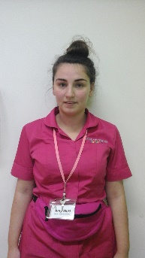

My name is **Niamh Heathcote**  and I will be your child’s key worker. I am an Early Years Practitioner in Daisy Room.

I have joined Auckland Team in October 2018. I am a level 6 qualified Early Years Practioner with a degree in early childhood studies.

In my spare time I enjoy socialising with my friends and family also doing active things.

Message from the Management team

**Contact Auckland House Day Nursery kelielever@aucklandcollege.com**

**Phone: 0151 727 0083 deputynurserymanager@aucklandcollege.com**

**Buttercups**

This month Buttercups have been focusing on different shapes and animals. Our song of the month was ‘Twinkle Twinkle Little Star’ and our story was ‘Squishy Squashy Dinosaur’. The children thoroughly enjoyed engaging in all of the different activities and had the opportunity to practice their gross motor development with a fun sensory obstacle course. Our babies have been exploring different textures, gluing and sticking them onto paper to create stars. The song ‘Twinkle Twinkle’ has all of the babies engaged and joining in by moving their bodies and opening and closing their hands. Our babies are growing in independence and are now beginning to pull to stand as well as taking a few steps. How fantastic!

**Daisy**

Our song for week one was Casper the friendly ghost. Children enjoyed painting ghosts, exploring marks and showing good fie motor skills. Children also enjoyed exploring the ghost themed tuff tray. children engaged well with others. The children enjoyed exploring themed tuff trays. of the three little men in a flying saucer. Children created saucers and spaceships using a range of materials. We also enjoyed making creations around ‘three little ducks’, the children enjoyed learning about ducks. We enjoyed reading a range of different stories, such as ‘tangled’, Goldilocks and the three bears. The night garden and little duck. Through exploring these children explored a range of creative activities. the children enjoyed reading the stories and making their own characters. They enjoyed making their own iggle piggles and had lots of fun making paper Mache ducks.

**Daffodil**

The Daffodil room have had lots of fun this month. They have enjoyed being very creative and made their own monsters after reading one of the stories. They have also been creating their own versions of sheep counting the cotton wool balls as they done this and also looked at quantities. Daffodil children have shown an interest in animals this month and have enjoyed creating their own favourite animals, learning colours as they done this. Miss polly had a dolly was a popular song and the children spoke about doctors and how they make us better. Also engaging in some role play with the dolls and learning how to look after them. Daffodil have also been exploring colours, learning about the different colours they can see and what happens when they mix some colours together.

**Snowdrop**

This month Snowdrop room have been super busy taking part in lots of fun and magical activities and experiences. We celebrated bonfire night, exploring a range of materials such as different coloured paints and glitter to create our own "fireworks", we created our own edible sparklers with breadsticks, melted chocolate and multi coloured sprinkles. We watched a virtual firework display and then enjoyed going into the garden and watching some real sparklers light up and shine! Our song we have been focusing on was 'Tiny Caterpillar on a Leaf'. We counted the parts of our caterpillars body and also focused on number recognition. We have used our imaginations and explored various materials to create our own caterpillars. We also went on a caterpillar hunt in the garden and found different insects along the way! Our story we have focused on has been 'Handa's Surprise'. We have learned about some exotic fruits that Handa finds on her journey and have tried to draw our own interpretation of these. We have spoken and learnt about different cultures. We celebrated 'Children in Need' day and dressed up in our special children in need clothes and raised some money for this. We created our own Pudsey masks using different materials.

**Bluebell**

Our song was Incy Wincy spider, the children loved decorating their own sliders I different ways such as painting, gluing and sticking and hand painting. We also hunted for spiders in different textures such as foam, mud etc. The children repeated lots of key words such as spider, Web, Incy Wincy. We sang Incy Wincy spider and copied the actions. Our story was ‘What's in my garden?’, we read the story to the children and they also looked through the book independently. We named the animals and the children repeated them. We used a variety of different creative activities to make our own animals which the children really enjoyed. Our theme was autumn, we had lots of 'autumn' activities exploring leaves, flowers etc and using them to make pictures. We made firework pictures using recycled materials, we made edible fireworks which the children particularly loved and we also put a fire out using spray bottles. We celebrated children in need wearing our pyjamas as having edible messy play Pudsy tuff tray. We made poppies for Remembrance day.

**Sunflower**

Sunflower enjoyed reading their story ‘How do dinosaurs learn colours and numbers’. The children showed great interest in the small world areas and using the dinosaurs to support and extend their learning. We used numbers during physical play to promote the children’s gross motor skills and number recognition and even used the tracing boards for the children to develop their fine motor finger muscles. Our song of the month was the alphabet song and the children enjoyed reciting this and also used the letter land letters to identify familiar letters. We celebrated some exciting festivals this month too including Diwali, Bonfire night and Remembrance Day. The children explored colourful tuff trays and discussed the importance of safety around fireworks.

**Contact Auckland House Day Nursery kelielever@aucklandcollege.com**

**Phone: 0151 727 0083 deputynurserymanager@aucklandcollege.com**

Facebook.com/AucklandHouseDayNursery

**We are on the Web!**

**Babysitting policy**

We do not provide a babysitting service outside our normal operating hours. However, we understand that parents sometimes ask nursery staff to babysit for their children and this policy has been implemented to clarify some points regarding private arrangements between staff and parents. Please also refer to our Safeguarding Children Statement.

* The nursery is not responsible for any private arrangements or agreements that are made: such agreements are between the staff member and family. However, we do expect staff members to inform us if they are babysitting or caring for a child that attends the nursery outside of the setting.
* We require the staff member and parent to sign a copy of this policy, which we will keep on file for the child and staff member.
* We have rigorous recruitment and suitability processes in place to ensure that we employ competent and professional members of staff and uphold our duty to safeguard children whilst on our premises and in the care of our staff. This procedure includes interviews, references, full employment history and DBS checks as well as several other processes. Whilst in our employment all staff are subject to ongoing supervision, observation and assessment to ensure that standards of work and behaviour are maintained in accordance with our policies. We have no such control over the conduct of staff outside of their position of employment. Parents should make their own checks as to the suitability of a member of staff for babysitting.
* We will not take responsibility for any health and safety issues, conduct, grievances or any other claims arising out of the staff member’s private arrangements outside of nursery hours. The member of staff will not be covered by the nursery’s insurance whilst babysitting as a private arrangement.
* Out-of-hours work arrangements MUST NOT interfere with the staff member’s employment at the nursery.
* All staff are bound by contract of the Confidentiality Policy and Data Protection Act that they are unable to discuss any issues regarding the nursery, other staff members, parents or other children.
* The nursery has a duty of care to safeguard all children attending the setting, so if a staff member has some concerns for a child following a private babysitting type arrangement they need to pass these concerns on to the Safeguarding lead within the setting.
* It will be the staff member’s responsibility to ensure they have the appropriate insurance, MOT and child restraints or child safety seats if they are transporting them in a car.



**Ingredients**

* **2 tbsp olive oil, plus a little for the dish**
* **750g lean beef mince**
* **90g pack prosciutto half quantity of our tomato sauce (see the recipe), or - 800g passata**
* **200ml hot beef stock**
* **a little grated nutmeg**
* **300g pack fresh lasagne sheets**
* **half quantity of our white sauce (see the recipe), or 520g ready-made sauce**
* **125g ball mozzarella, torn into thin strips**

**Method**

1. To make the meat sauce, heat 2 tbsp olive oil in a frying pan and cook 750g lean beef mince in two batches for about 10 mins until browned all over.
2. Finely chop 4 slices of prosciutto from a 90g pack, then stir through the meat mixture.
3. Pour over 800g passata or half our basic tomato sauce recipe and 200ml hot beef stock. Add a little grated nutmeg, then season.
4. Bring up to the boil, then simmer for 30 mins until the sauce looks rich.
5. Heat oven to 180C/fan/160C/gas 4 and lightly oil an ovenproof dish (about 30 x 20cm).
6. Spoon one third of the meat sauce into the dish, then cover with some fresh lasagne sheets from a 300g pack. Drizzle over roughly 130g ready-made or homemade white sauce.
7. Repeat until you have 3 layers of pasta. Cover with the remaining 390g white sauce, making sure you can’t see any pasta poking through.
8. Scatter 125g torn mozzarella over the top.
9. Arrange the rest of the prosciutto on top. Bake for 45 mins until the top is bubbling and lightly browned.

**Recipe of the month – Home made Lasagne**

Cooked by our Chef Claire

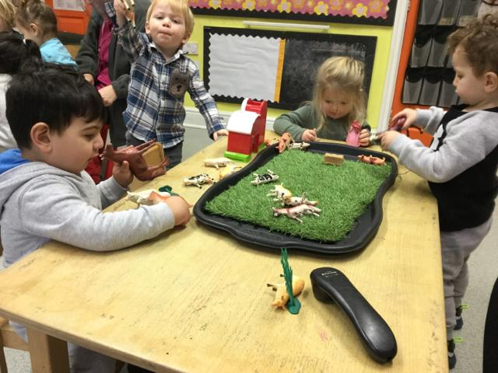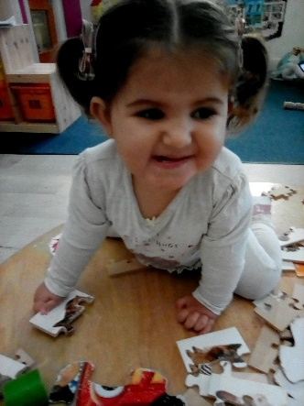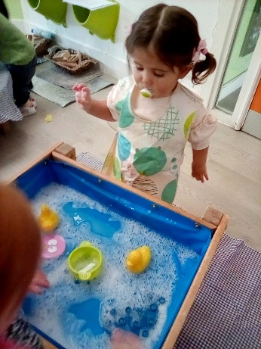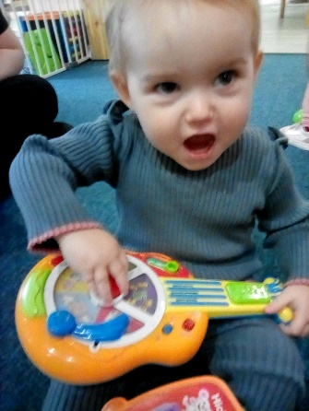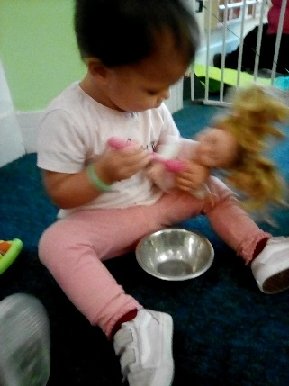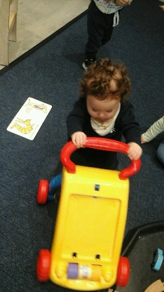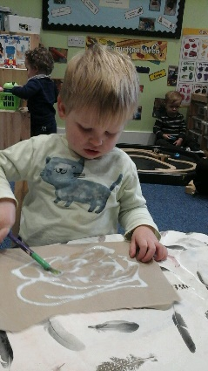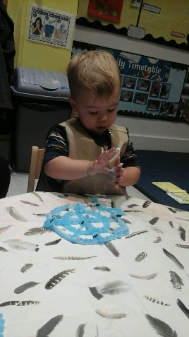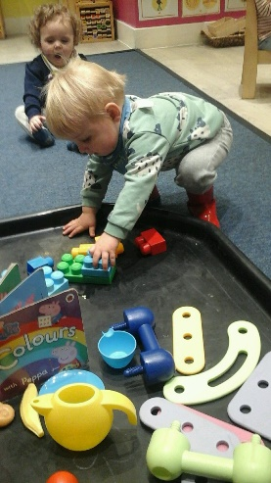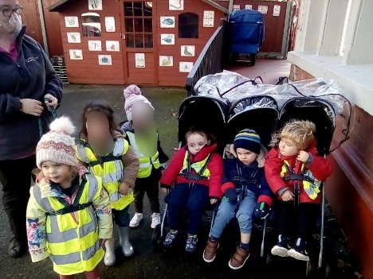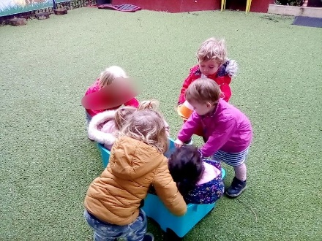



**Contact Auckland House Day Nursery kellielever@aucklandcollege.com**

**Phone: 0151 727 0083 deputynurserymanager@aucklandcollege.com**